Analysis of Conjugated Structure influence   
on   
Excited State Dynamics

(cis,cis-1,3-cyclooctadiene)

Matsika Group  
 Khai Nguyen  
khainguyen@temple.edu

1. **Goal**

This work tries analyzes the internal coordinates of cis,cis-1,3-cyclooctadiene to understand how the structure of conjugated system affect its photo-isomerization products in non-adiabatic processes.

1. **Background**

*Light-induced isomerization* currently plays a key role in creating molecular switches or molecular machines, where light aids in conversion between different stable forms or configurations of a molecule. Applications can be seen in photo-responsive biological functions and processes in light-absorbing proteins such as vision, photosynthesis, and DNA repair.

This analysis particularly assesses cis,cis-1,3-cyclooctadiene (COD) (*Fig. 1*) as the experimental subject due to the presence of the C6=C7-C8=C1 *conjugated system* in its structure. Conjugated system is a system of connected p-orbitals with delocalized electrons in a molecule. Conjugated system is conventionally represented as having alternating single and multiple bonds. Lone pairs, radicals or carbenium ions may be part of the system, which may be cyclic, acyclic, linear, or mixed. The largest conjugated systems are found in graphene, graphite, conductive polymers, and carbon nanotubes.

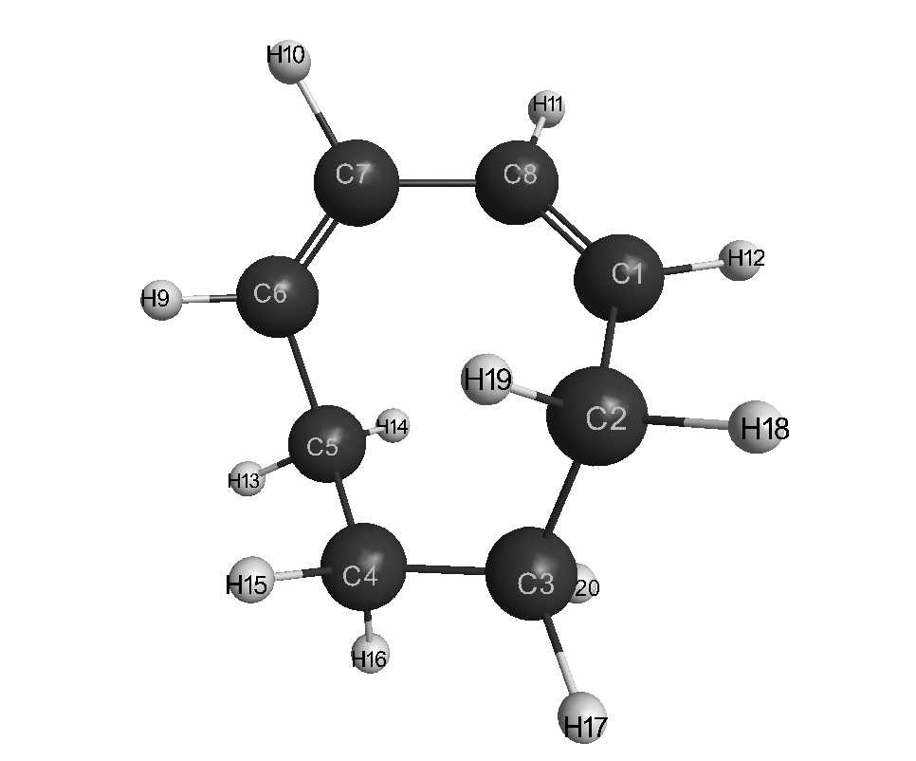*Fig. 1 cis,cis-1,3-cyclooctadiene (COD)*

1. **Protocol**
   1. **Computational methods**

MacMolPlot1 software was used to visualize the molecule trajectories from xyz-coordinate input files. JupyterNotebook2 was used as the development platforms for the computational and visualization scripts, which were written in Python 3.6. All scripts are hosted on Github.

* 1. **Data**

The input xyz-coordinate data files are also hosted on Github, including:

* IC-angs-conflow.xyz (Initial S0 data)
* del-hop21-cartesian-updated.xyz (Data at S1/S0 hop)

1. **Results and Discussion**
   1. **C-C Bond Lengths**

|  |  |
| --- | --- |
| *Figure 2a.* | *Figure 2b.* |

From *Fig. 2a. &2b*., the value of two double bonds C6=C7 and C8=C1 spread out on a larger range of 1.2 - 1.8 Å compared to the single bonds. The distribution shape is also clearly displayed in *Fig. 2c.& 2d.*

|  |  |
| --- | --- |
| *Figure 2c.* | *Figure 2d.* |

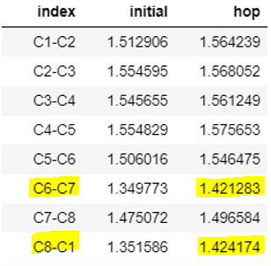*Table 2e. Average value of C-C bonds at initial and at hop*

It is also observed that the double bonds, which are initially shorter than the single bonds, shift towards the 1.4 Å average at hop compared to the average of 1.55 Å for single bonds at hop (*Table 2e.).* Another point to note from *Table 2e.* is the value for the C7-C8 single bond that lies between the double bonds. It varies at around 1.48 Å, between what we would expect for a C-C π bond (~1.42 Å) and a C-C single bond (~1.55 Å). This displays the effect of conjugation with respect to bond length. The bond length of single bond C7-C8 decreases as it gets some double bond character, and the bond length of double bonds C6-C7 and C8-C1 increase as they lose some double bond character3.

* 1. **C-C-C angles**

|  |  |
| --- | --- |
| *Figure 3a.* | *Figure 3b.* |

For cyclooctadiene (COD), the sum of the measure of the interior angles of is (n - 2) * 180 = 10800 with n = 8 being number of geometric sides, which results in the initial value of the C-C-C being between 1100 – 1350.

One thing to notice is compared to the clustering pattern of most C-C-C angles, which only change their average by ±20, the angles at C6-**C7**-C8 and C7-**C8**-C1 changes more dramatically at hop (*Figure 3.b* and *Table 3c.*), with those angles at-hop distributing from 500 – 1500 from their initial average value of ~124.50.

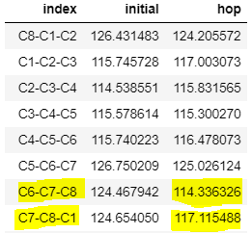  
*Table 3c. Average value of C-C-C angles at initial and at hop*

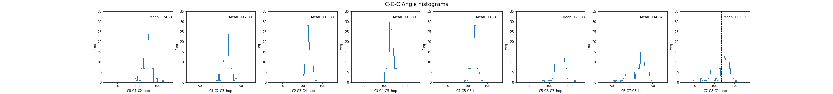  
*Figure 3d. Histograms for C-C-C angles*

Also worth noticing is that the values for C5-C6-C7 also got spread out rather than peaking at the mean value like the angles centered at the C1, C2, C3, C4, and C5 carbons (*Figure 3d.*). This partly explains the preference of COD to have dihedral twisting localized on one bond (discussed in section **4c**)). Examining the distribution of the C-C-C angles centered at C1 and C6 (C8-C1-C2 and C5-C6-C7) shows that their values are less scattered than the ones centered at C7 and C8, despite C1 and C6 being part of the double bonds in COD. This behavior correlates to the preference of COD to have inner pyramidalization, centered at C7 and C8 4.

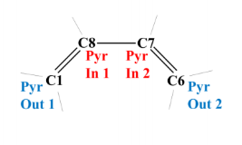

*Figure 3e. Outer pyramidalization angles Pyr Out 1 (pyramidalization at C1) and Pyr Out 2*

*(pyramidalization at C6) defined in terms of dihedral angles C2-C1-H12-C8 and C7-C6-H9-C5, respectively.*

*Inner pyramidalization angles Pyr In 1 (pyramidalization at C8) and Pyr In 2 (pyramidalization at C7)*

*have been defined in terms of dihedral angles C1-C8-H11-C7 and C8-C7-H10-C6, respectively.4*

However, none of the angle reaches 1800 at hop so far in the experiments.

* 1. **Dihedral Angles**

While assessing the dihedral angles, the absolute values were computed. For both dihedrals, their value initially starts close 0o, then spread out from 00 to the observed upper twisting threshold of 1700 at the hopping point (*Fig. 4a*). At hop, 81.75% and 80.29% of the dihedral twists lies between 00-900 degree for H9-C6=C7-H10 and H11-C8=C1-H12 respectively, giving the average twist value for both dihedrals between 450-500 (*Table. 4b*).

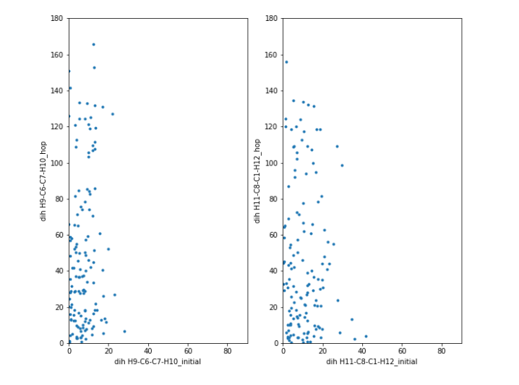  
*Figure 4a.*

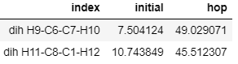  
*Table 4b.*

Further discussion on the twisting of the two dihedrals should also mention that S1/S0 conical intersections involve both cases of: having only one double bond (local) twisting, or having both double bonds twisting at the same time. The pattern (in *Fig. 4*c) indicates that in most cases only one double bond twists. Only 16% of the hops have both dihedrals twisted.4

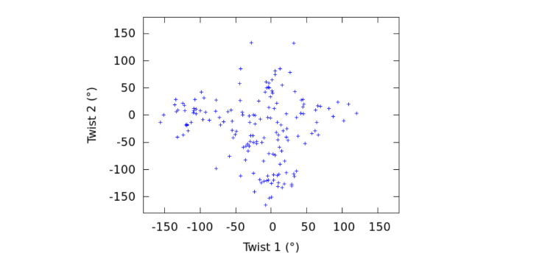

*Figure 4c. Correlation between the two dihedral angles defining twisting around the double bonds*

*at all the S1-> S0 hopping geometries.*

*Twist 1 and Twist 2 are defined as the dihedral angles H11-C8=C1-H12 and H9-C6=C7-H10, respectively.4*

1. **Future work**

For analytic subjects, continued work to in understanding how the structure of conjugated systems affects their excited state dynamics involves extending the analysis to other molecules, Cis,cis-1,3-cyclooctadiene (cc-COD) is a cyclic π-conjugated diene, but is larger and more flexible compared to 1,3-cyclohexadiene CHD and butadiene (BD). We wanted to compare the dynamics of cc-COD to those of CHD and BD, assessing whether the excited state dynamics localized on individual double bonds, or delocalized on both bonds. In addition, we also want to understand how the conjugated structure affects the excited state dynamics of these molecules.

For analytic methods, internal coordinate analysis will be a starting point, but more analytics methods will be added on as the research proceeds.

1. **Conclusion**

Through this analysis, the changes in the bond lengths, C-C-C angles, and dihedral angles at the

S1/S0 hop were assessed. The excited state dynamics are demonstrated through the changes on the C-C-C angles and the dihedral angles, and mainly located at the C7 and C8 inner carbons of the π bonds in the conjugated structure. It is still not yet clear how the conjugated structure affected the behavior of COD, so extending future work onto other molecules is needed.

**References**

1. Bode, B. M. a. G., M. S *J. Mol. Graphics Mod.,*.

2. *Jupyter Notebook*.

3. Ashenhurst, J. Conjugation And Resonance In Organic Chemistry. [https://www.masterorganicchemistry.com/2017/01/24/conjugation-and-resonance/.](https://www.masterorganicchemistry.com/2017/01/24/conjugation-and-resonance/)

4. Chakraborty, P.; Liu, Y.; Weinacht, T.; Matsika, S., Excited state dynamics of cis,cis-1,3-cyclooctadiene: Non-adiabatic trajectory surface hopping. *J Chem Phys***2020,** *152* (17), 174302.